**Resume of**

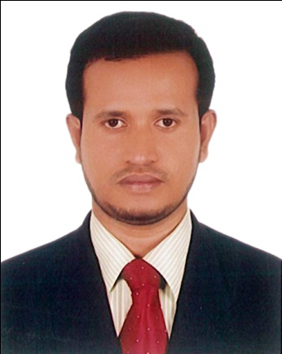

**Md. Rahim Ullah Khondaker**

**Mailing Address:**

C/O : Maidul Islam Chy

DyManager (Accounts)

Electro Mart Ltd.

Noor Holding (level-07)

Gulshan.01

Dhaka-1212

Mobile: 01755889689,01818785552

**Career Objective**

To obtain a position in a progressive organization that will utilize my educational background. Challenges my abilities and enhance my knowledge. A desire to contribute effectively through motivation, discipline and hard work to reach the top level.

**Personal Information :**

* Father’s Name : Md. Mainuddin Khondaker
* Mother’s Name : Peara Begum
* Permanent Address : Vill: Motua, Ward No-08,

P.O: Chhagalnaiya,

Thana : Chhagalnaiya, Dist: Feni.

* Date of Birth : 5th August 1980
* Nationality : Bangladeshi by birth
* Religion : Islam
* Blood Group : B+ve
* Contact Phone : 01818785552,01759130289

**Qualification Information :**

**MBA.**

Institute : FIU

Subject : Marketing & Finance

University : Private University

Result (CGPA) : 3.28

Passing Year : 2017

**B.A (Hon’s)**

Institute : DIU

Subject : Islamic Studies

University : Private University

Result (CGPA) : 3.55

Passing Year : 2007

**Higher Secondary Certificate (H.S.C)**

Institute : Feni Govt. College.

Group : Business Studies

Result : 2nd Division

Board : Comilla

Passing Year : 1999

**Secondary School Certificate (S.S.C)**

Institute : Chhagalnaiya Pilot High School.

Group : Science

Result : 1st Division

Board : Comilla

Passing Year : 1996

**Computer Experience:**

* Familiar with WINDOWS based Packages Like (MS. Word, MS Excel, etc.

**Language Skill**

* Proficiency at understanding, Speaking, Reading & Writing Both Bengali & English.

**Jobs Experience:**

* I Served as Officer VAT 07 Since April-2007 to 30, July 2014 Uttara Motors Ltd (Corporate & Eskaton Branch) Dhaka.

* I have been working as Executive Finance (VAT) Grade-2,Nippon Paint (BD) Pvt. Ltd. Japan Based Company (1877) Since 03 August, 2014 to 02 May,2018 till now.
* I have been working as Sr,Executive (VAT) Uttara Motors Ltd 23/ka Eskaton,Dhaka-1000. 03 May,2018 to till now.

|  |  |  |
| --- | --- | --- |
| **Reference :**  **Shamsul Karim Chy-FCA**  CFO & Admin  Kazi Farms Ltd.  Dhanmondi, Dhaka.  Mob :01713101199 |  |  |

**Md. Rahim Ullah Khondaker**